Registration Process for Employers
ELIGIBILITY
All Employers MUST:
- Be operating within the Glasgow City Council boundary
- Employ fewer than 250 employees
- Be a private company, social enterprise or third sector organisation
- Hold current public and employers’ liability insurance
- Be able to provide payslips, and where requested, payroll run and business bank statements
- Agree to only recruit from our pool of candidates
- Adhere to Fair Work First commitments which includes payment of the Real Living Wage (including apprentices) and providing appropriate channels of effective workers’ voice
- Not have any outstanding debt to Glasgow City Council - approval is dependent on your Non-Domestic rate account being up to date
Our Employer Recruitment Incentive is not intended to assist you to afford to recruit a candidate, therefore you must be able to demonstrate your organisation is financially stable and can offer a sustainable job opportunity.

REGISTRATION PROCESS

The registration process includes the following steps:
- Online Registration Form
- Providing a copy of Liability Insurance
- Providing a copy of a business plan if the business is trading for less than one year
- Non-Domestic Rates Check and/or copy of lease

Employers will have access to their account but WILL NOT be able to create a vacancy, until all the above areas are complete, and the registration has been approved by a Glasgow Guarantee Business Advisor

Registrations can only be approved once all steps have been completed and all forms/documents are accepted.

GETTING STARTED
To register with Glasgow Guarantee, go to www.glasgowguarantee.org and click on #READY TO RECRUIT? to complete the registration information page.

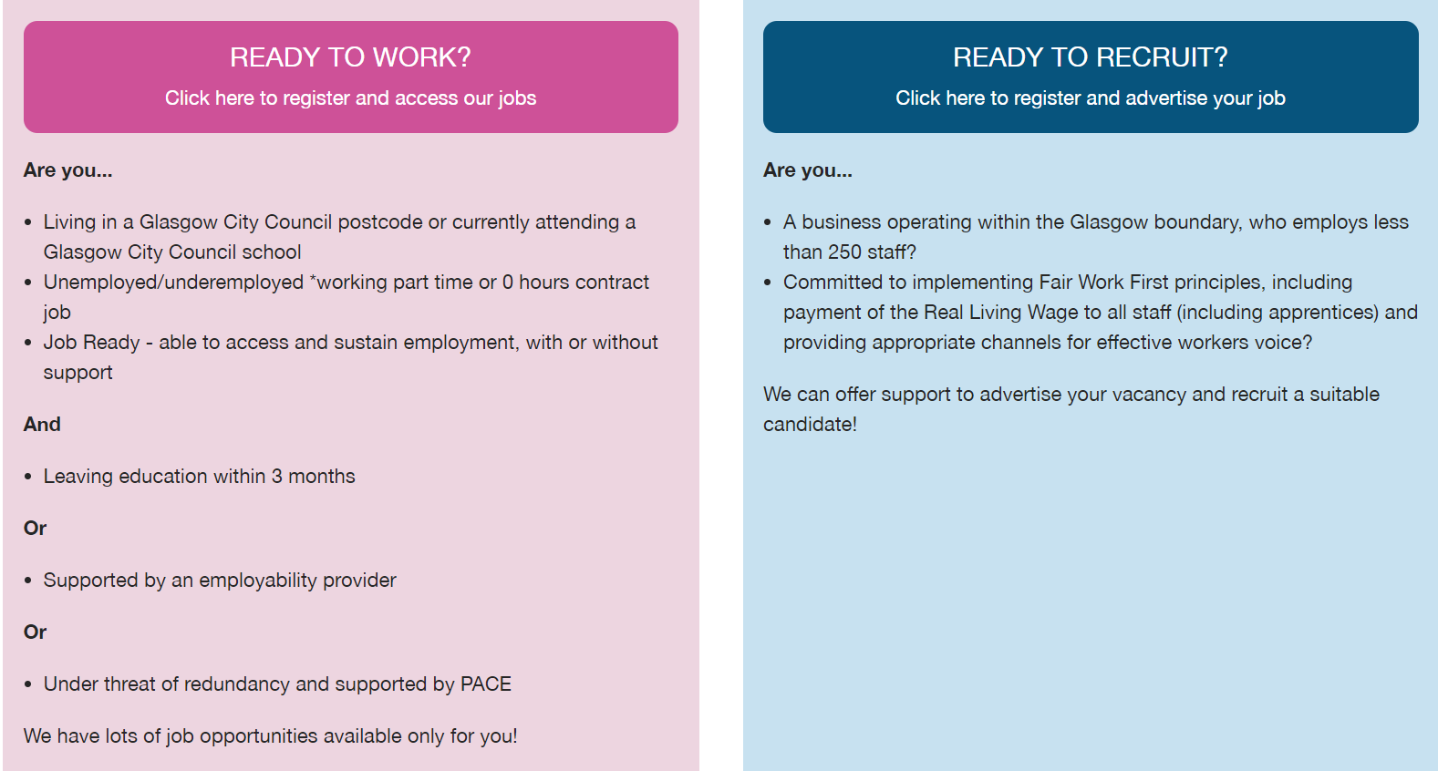

PRIVACY POLICY
You are giving us your personal information to allow us to assess the evidence of the eligibility of your business for the Glasgow Guarantee scheme, which includes National ERI access.

We have a Privacy Policy which explains how we keep your information. To find out how we will process and use your information, go to https://www.glasgowguarantee.org/Home/PrivacyPolicyBusiness

STEP 1: ONLINE REGISTRATION FORM

The online registration form consists of eligibility questions, which require a Yes or No answer. Some answers may deem your business ineligible for Glasgow Guarantee funding, and this will be highlighted where appropriate below.

Postcode Check

- Enter a valid Glasgow City Council postcode. To check that the postcode is within Glasgow City, please access www.gov.uk/find-local-council
- Click on ‘Find Address’
- Select from the address drop down
- If your postcode is not recognised, please contact guarantee@glasgow.gov.uk

Eligibility Questions

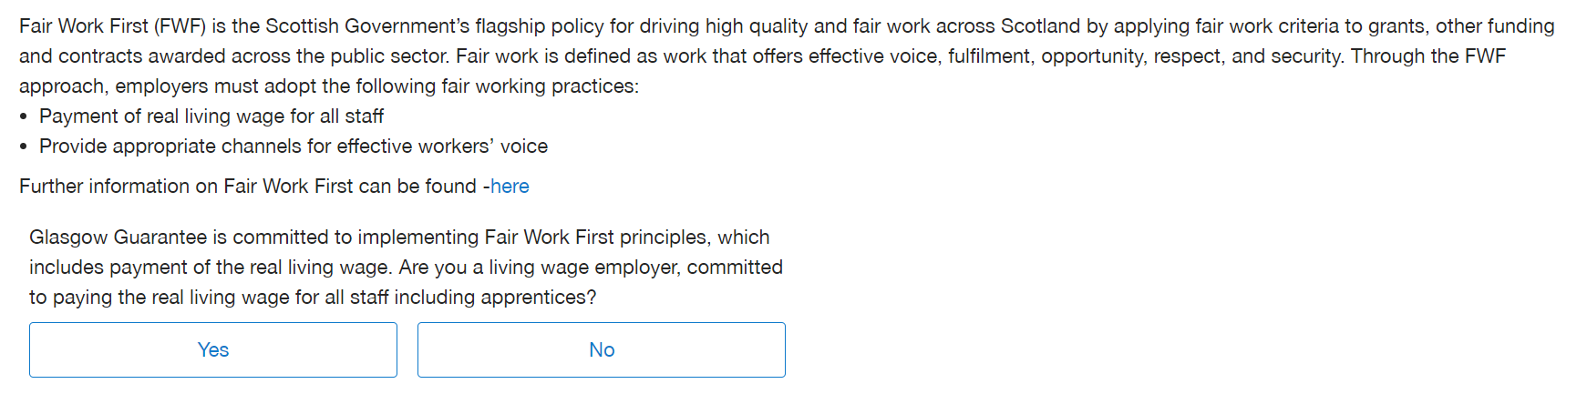

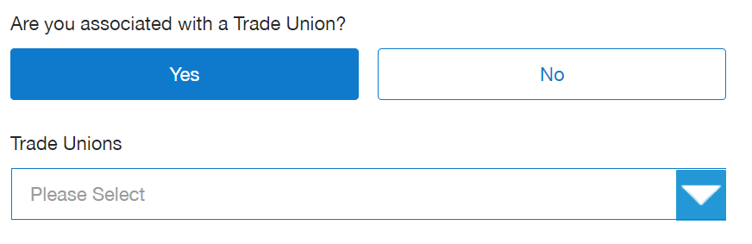
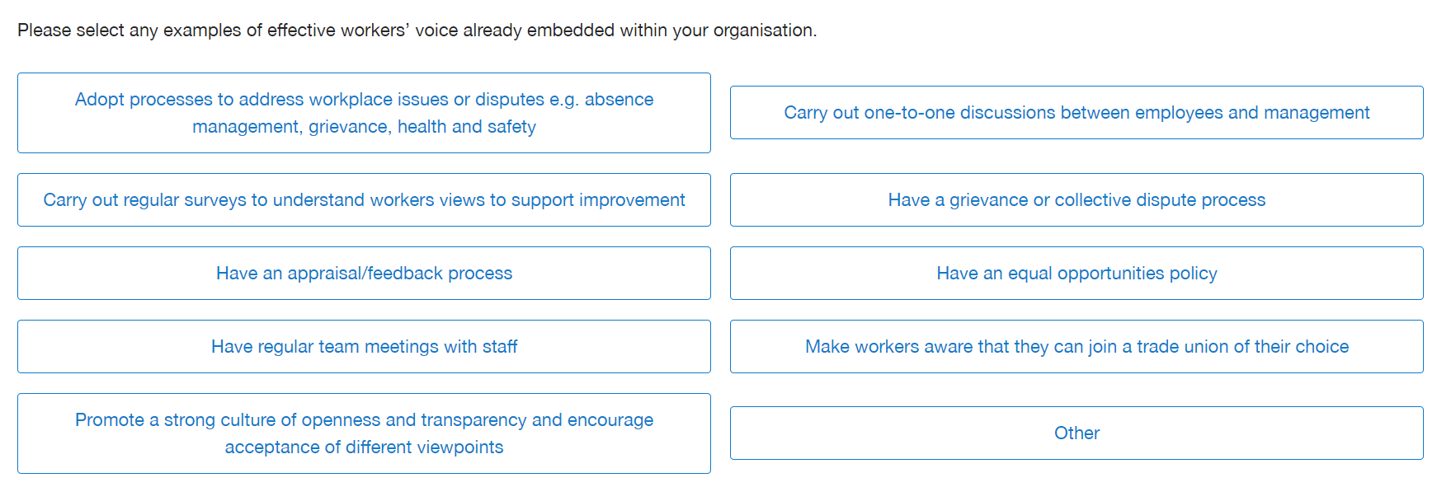

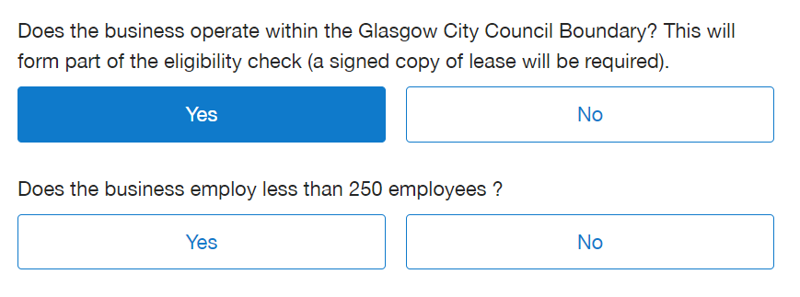
- Answering No to the questions above will deem your business ineligible.

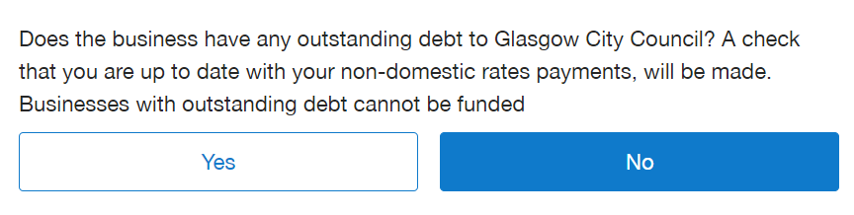

- Answering Yes to the question above will deem your business ineligible.

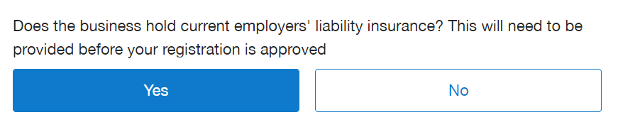
- If you do not hold employer’s liability insurance, your business will not be eligible.

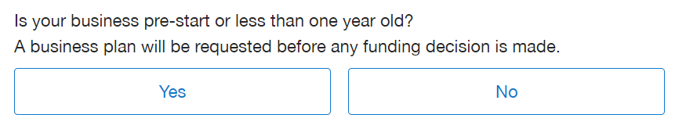
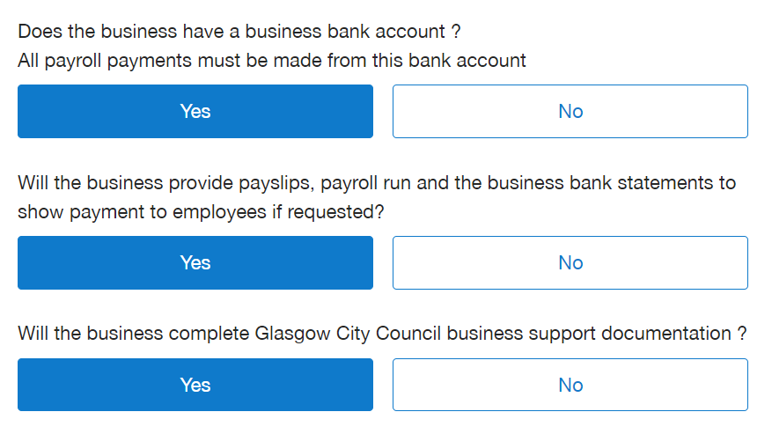

- Businesses who recruit via Glasgow Guarantee will receive paperwork to complete, prior to a Grant Award Letter and Grant Claim Forms being issued
- Claims are made 3 months in arrears
- Glasgow Guarantee Finance require copies of payslips, payroll run and business bank account statements, showing payments to a Glasgow Guarantee successful candidate
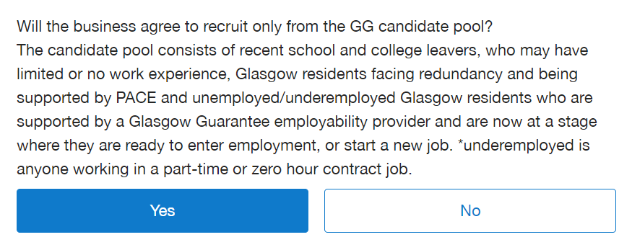
- Business must recruit from the Glasgow Guarantee pool of eligible candidates.
- Businesses who have sourced their own candidate will not be funded, unless the candidate is undertaking a work placement, which was organised by one of Glasgow Guarantee’s approved employability providers.

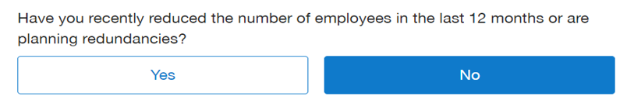
- Glasgow Guarantee will not fund business who have recently reduced their employee numbers, or are planning redundancies

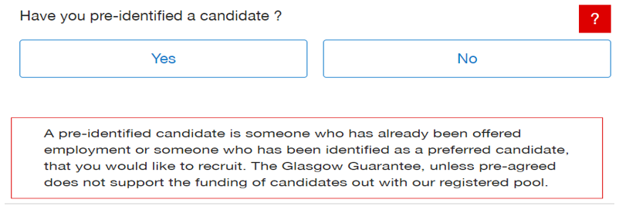
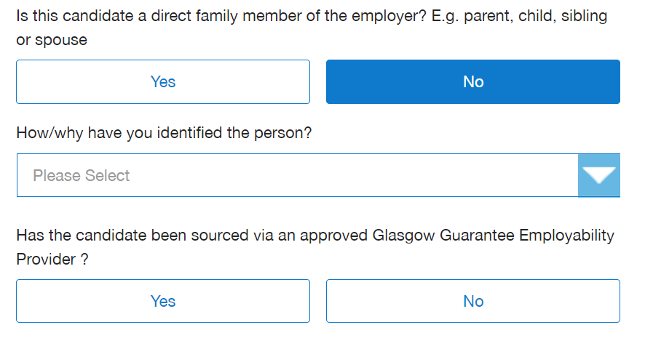
- Businesses who have sourced their own candidate will not be funded, unless the candidate is undertaking work placement, which was organised by one of Glasgow Guarantee’s approved employability providers.
- To be eligible the business must have not identified a candidate who is a direct family member

STEP 1: COMPANY DETAILS

- Enter your company details, including your business contact details
- Create a username and password, which you will use to access your Glasgow Guarantee account

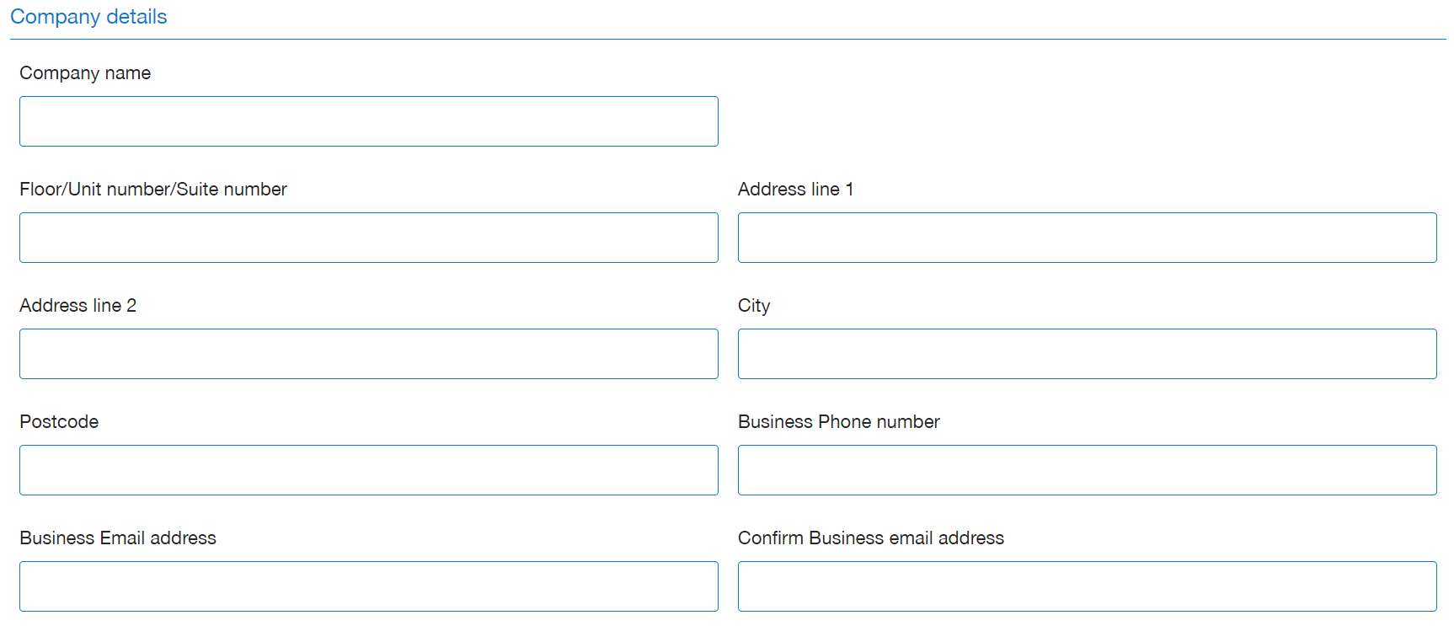
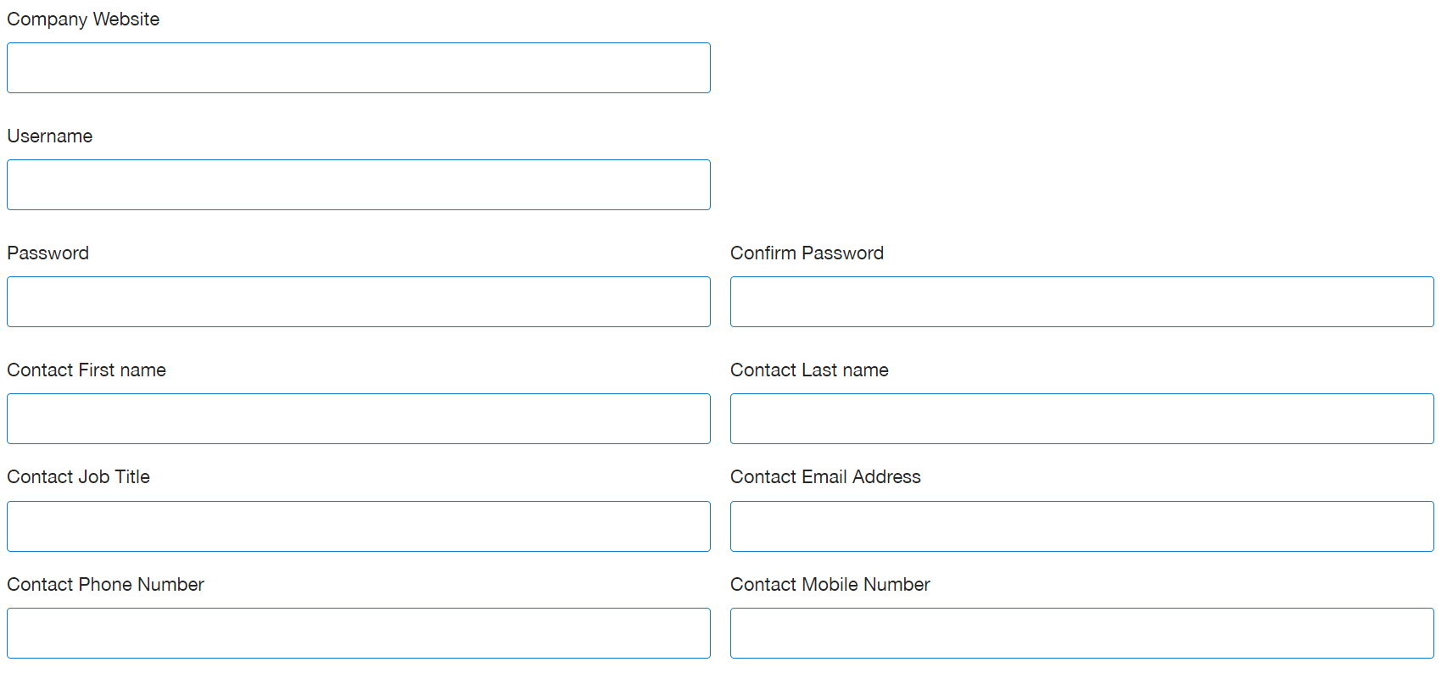

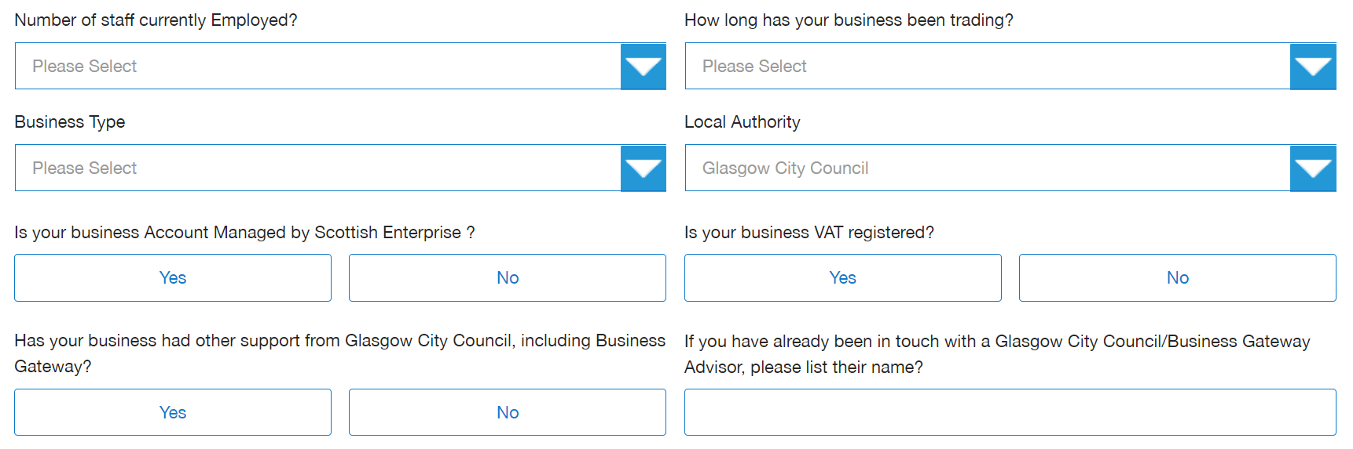
Select from the dropdown:
- Number of staff currently employed
  - 1-5
  - 6-9
  - 10-19
  - 20-49
  - 50-100
  - 101-249
  - 250+

- How long has your business been trading
  - Pre-Start
  - 0-12 Months
  - 1-2 Years
  - 2-5 Years
  - 5 Years+

- Business Type
  - Charity
  - Community Interest Company
  - Co-Operative
  - Limited Company
  - Limited Liability Partnership
  - Partnership
  - Pre-Start
  - Public Limited Company
  - Social Enterprise
  - Sole Trader

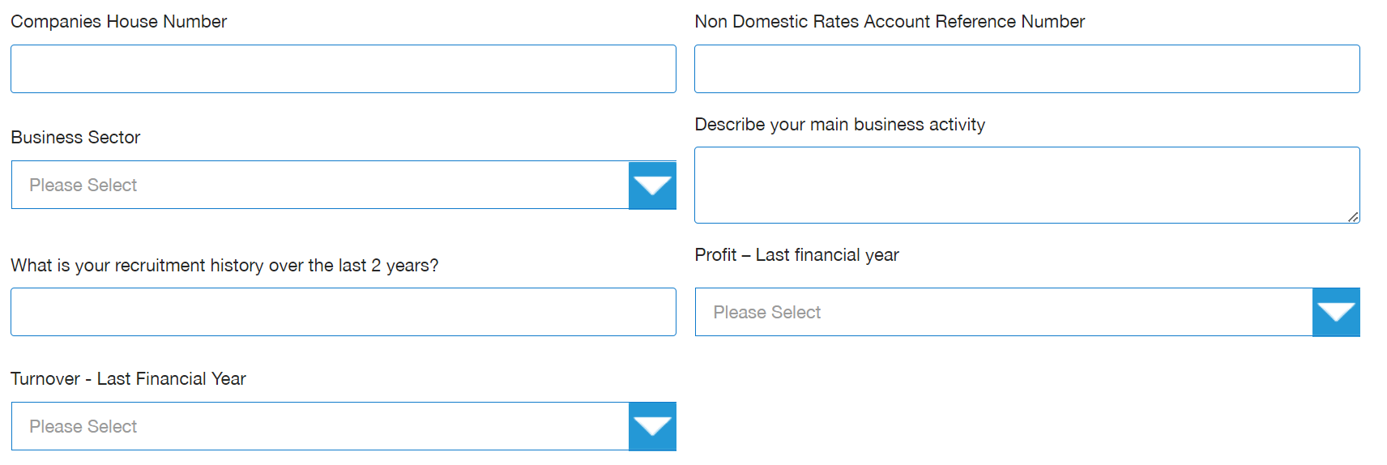

- Companies House Number
  - You can find this on your certificate of incorporation and any official documentation received from Companies House. Your CRN is also displayed on the public register of companies, which can be accessed online via Companies House Service https://find-and-update.company-information.service.gov.uk/

- Non-Domestic Rates Reference Number
  - Will be on any correspondence/email from NDR team but if this is not known, please leave this section blank.

- Business Sector
  - Select as appropriate from the dropdown
  - This is the sector your business operates within

- Please provide details of your profit and turnover for the last financial year from the drop-down options:
  - £0 - £85,000
  - £85,000 - £250,000
  - £250,000 - £500,000
  - £500,000 - £1M
  - Over £1M

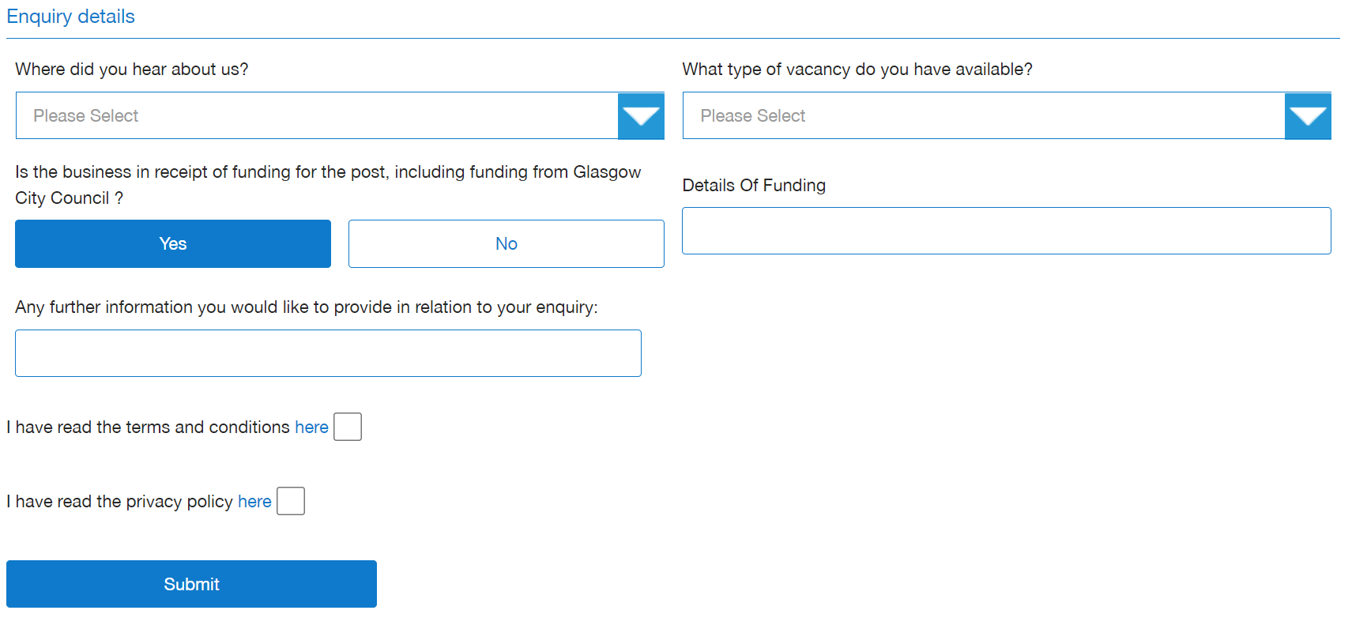

Select from the dropdown:
- Where did you hear about us?
  - Select as appropriate

- What type of vacancy
  - Modern Apprenticeship
  - Part Time Job
  - Vacancy

- Is the business in receipt of funding for the post, including funding from Glasgow City Council?
  - If yes, please provide details

- Please read the Terms and Conditions and Privacy Policy and tick the box once read

- Submit

This completes the Glasgow Guarantee Online Business Registration process. A Business Advisor will be in contact to discuss your recruitment needs and to request any relevant eligibility documents, which can include:
- Copy of Employers Liability Insurance
- Copy of Business Plan (if trading less than 1 year)
- Copy of Lease/NDR Check

Once your registration is approved, you can create and advertise your vacancy – please see Guide to Creating a Vacancy in the Downloads section of your Glasgow Guarantee account

