GLASGOW GUARANTEE

Vacancy Search and How to Apply

**HOW TO SIGN IN TO YOUR ACCOUNT**

When you register with Glasgow Guarantee, you will have created your own username and password. Use these details to **Sign In** to your Glasgow Guarantee account.

Please go to [www.glasgowguarantee.org](http://www.glasgowguarantee.org) and click on **Sign In**

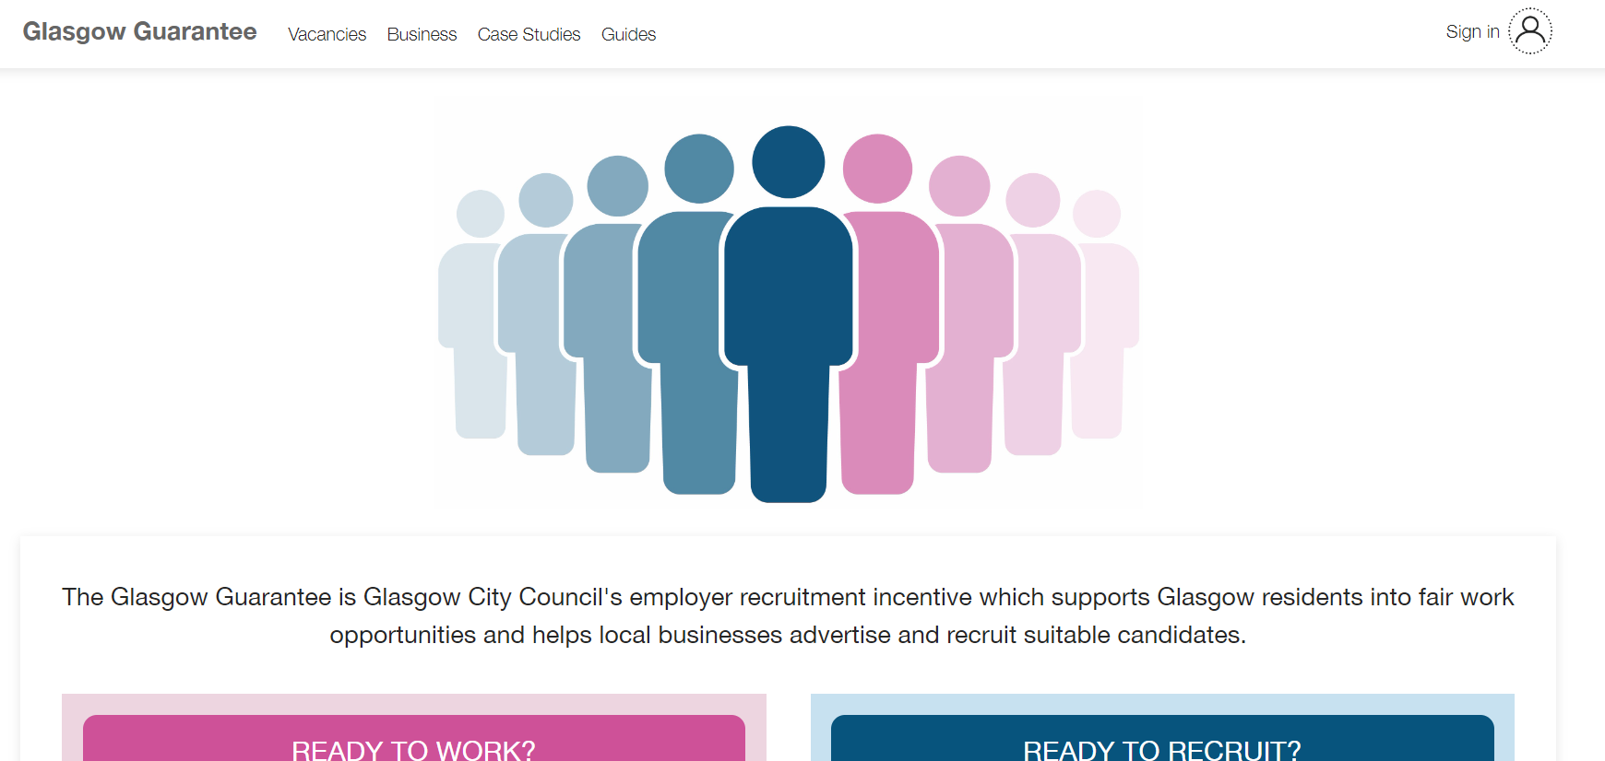

If you have forgotten your username and/or password, click on the **Forgotten Password** icon

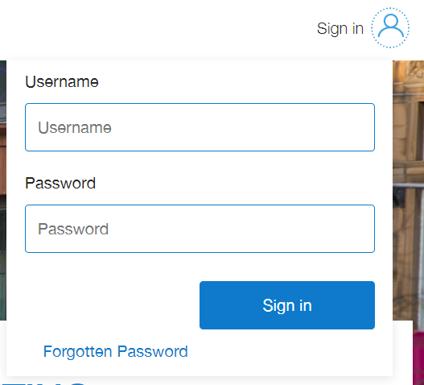

**HOW TO FIND VACANCIES**

When you have signed into your account, click on **Vacancies** at the top left of your account to open the list of available job and modern apprenticeship opportunities

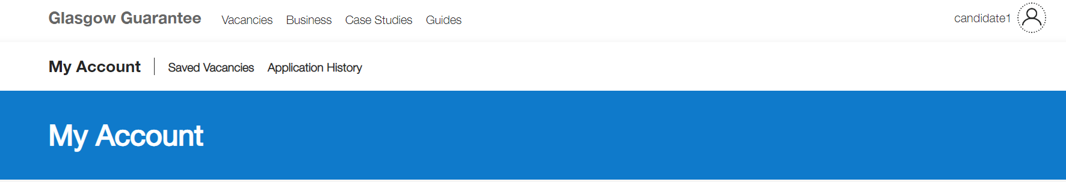

You can search for jobs and modern apprenticeships using the available filters:

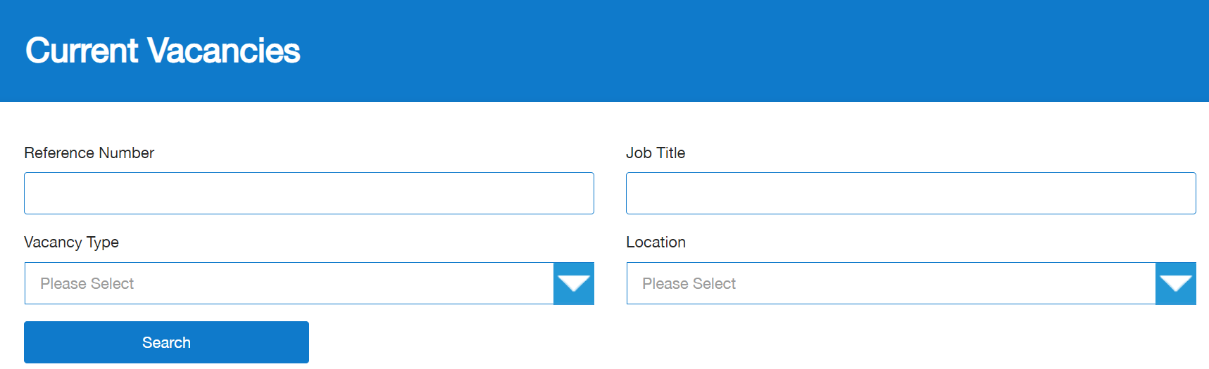

Or you can scroll through the list of vacancies:

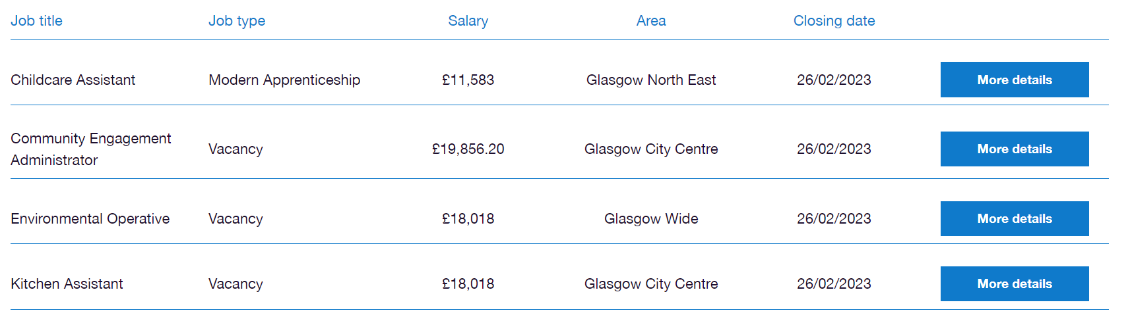

**HOW TO SAVE A VACANCY**

To find out more about the job and/or modern apprenticeship that interests you, click on ‘**More details’.** This will open the full job description



If you cannot apply right away and want to save the vacancy and apply later, click on **‘SAVE VACANCY’** at the bottom of the job description.

You can find all your saved vacancies in your account:



**MY ACCOUNT**

In your account, you can add certain information about you:

* **Qualifications**
* **Work Experience**
* **Key Skills**
  + The information you provide in these 3 areas will be automatically copied into the online Glasgow Guarantee application form
  + You will have the option to edit/amend these areas within the application form

**HOW TO ADD QUALIFICATIONS**

You can add qualifications by clicking on the **‘Qualifications’** icon in your account

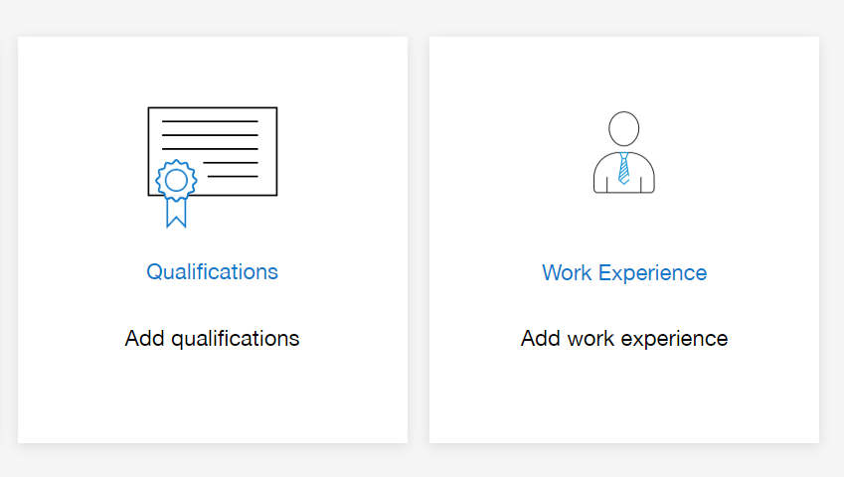

You will need to create the education establishment you attend/attended, for example your school or college etc.

You can do this by clicking on **Qualifications** in your account and selecting **Create My Establishment**

* Establishment Type - select school / F/HE / Other
* Establishment Name - select your school / college / university
* Date From/Date To - enter the dates you attended
  + If you haven’t left school/college, enter the date you will leave

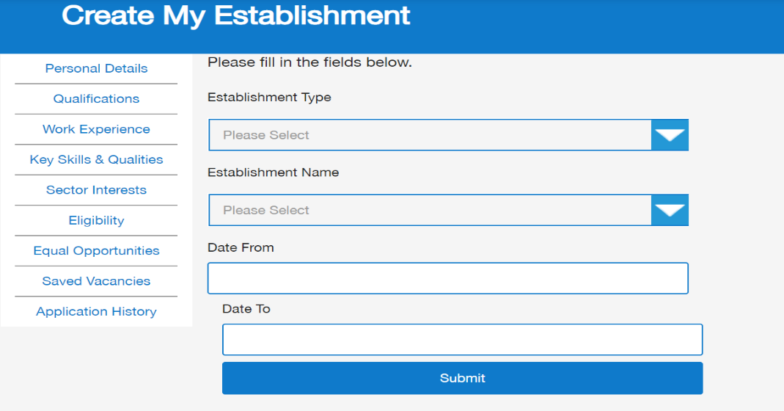

Click on **Create Qualification**

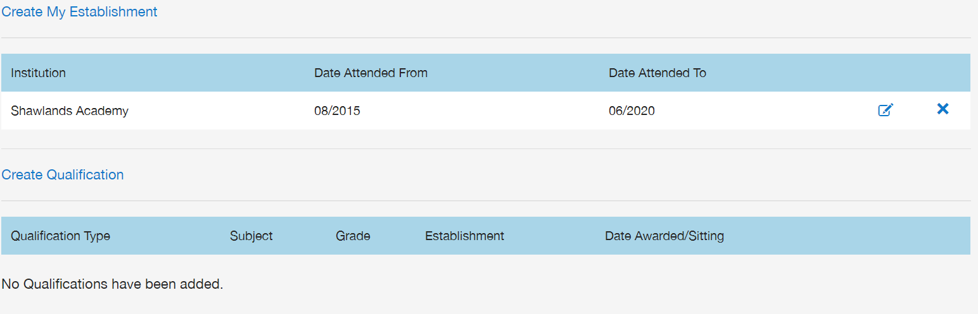

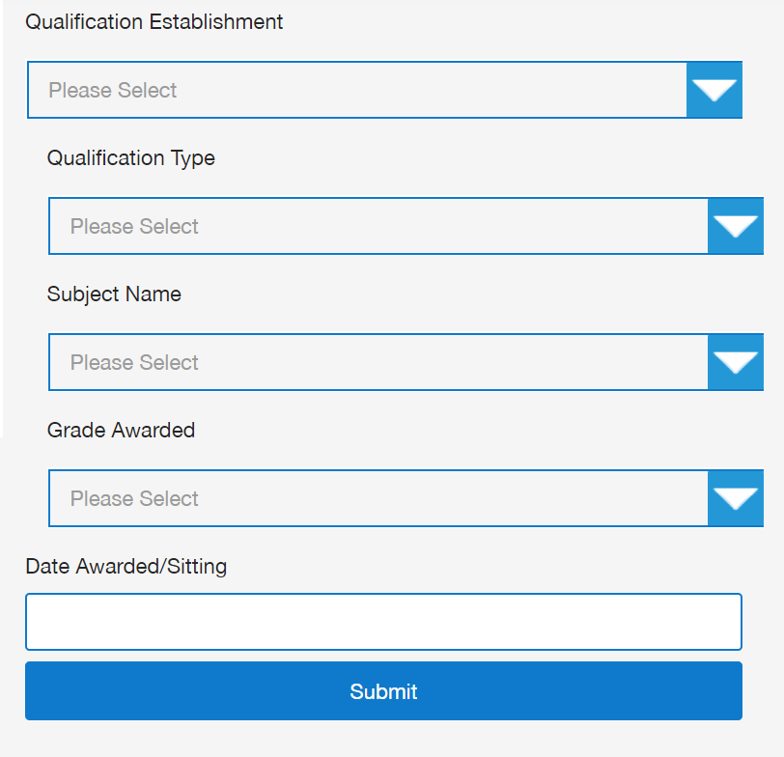

* Qualification Establishment – select your school / college / university
* You can select your qualification type, subject name, and grade awarded
  + If you haven’t received your grade yet, please select ‘Pending’
  + Enter the date you were awarded the grade or the date you will be sitting your exam

**HOW TO ADD WORK EXPERIENCE**

You can add details of any voluntary, paid and unpaid work experience by clicking on the **Work Experience** icon in your account and entering the details:

* Job Title
* Employer Name
* Start Date
* End Date
* Job Description



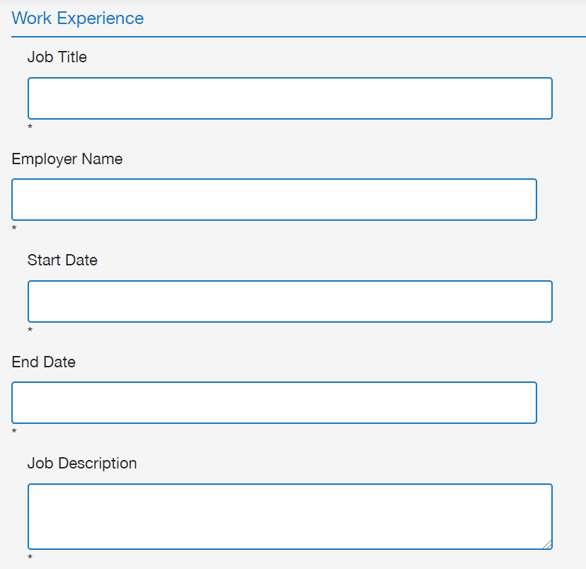

**HOW TO ADD KEY SKILLS AND QUALITIES**

You can add details of your key skills and qualities by clicking on the **Key Skills** icon in your account.

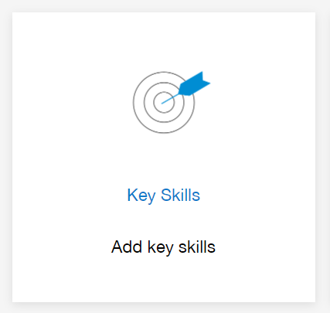

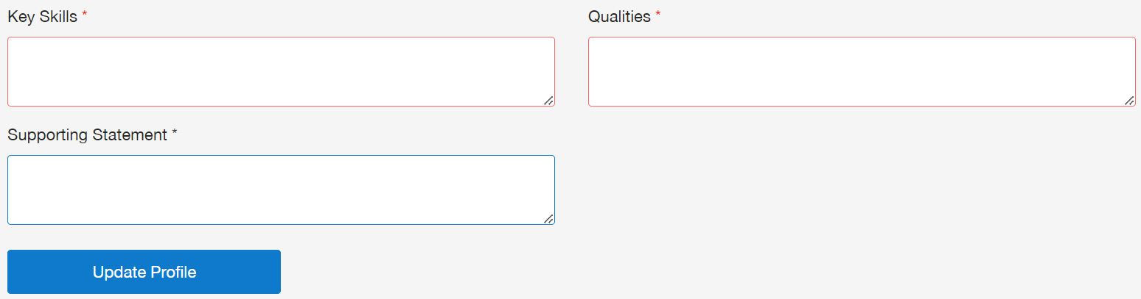

What to consider:

* What key skills and qualities do you have, which are relevant to the role you are applying for?
* Look at the job description and think about what you need to be good at, to do the job/apprenticeship.
* Give examples of things you have done or studied that show your skills and qualities, which match the job/apprenticeship you are applying for.
* Some examples of skills are teamwork, organisation, customer service, communication, IT literate, time management and problem solving.
* Some examples of qualities are honesty, kindness, good work ethic, loyalty, trustworthiness, responsibility, and reliability.

**HOW DO I APPLY?**

When you have found an apprenticeship or job opportunity that you want to apply for, please click the **‘Apply’** button at the bottom of the job description.

**THE APPLICATION FORM**

To apply for a job or modern apprenticeship, you will be asked to either complete the online application form, or to upload your CV and covering letter.

The online application form will look like the following:

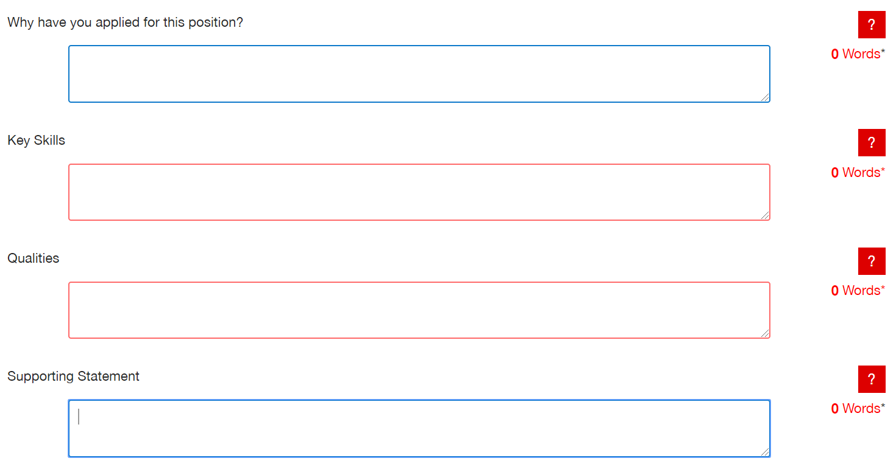

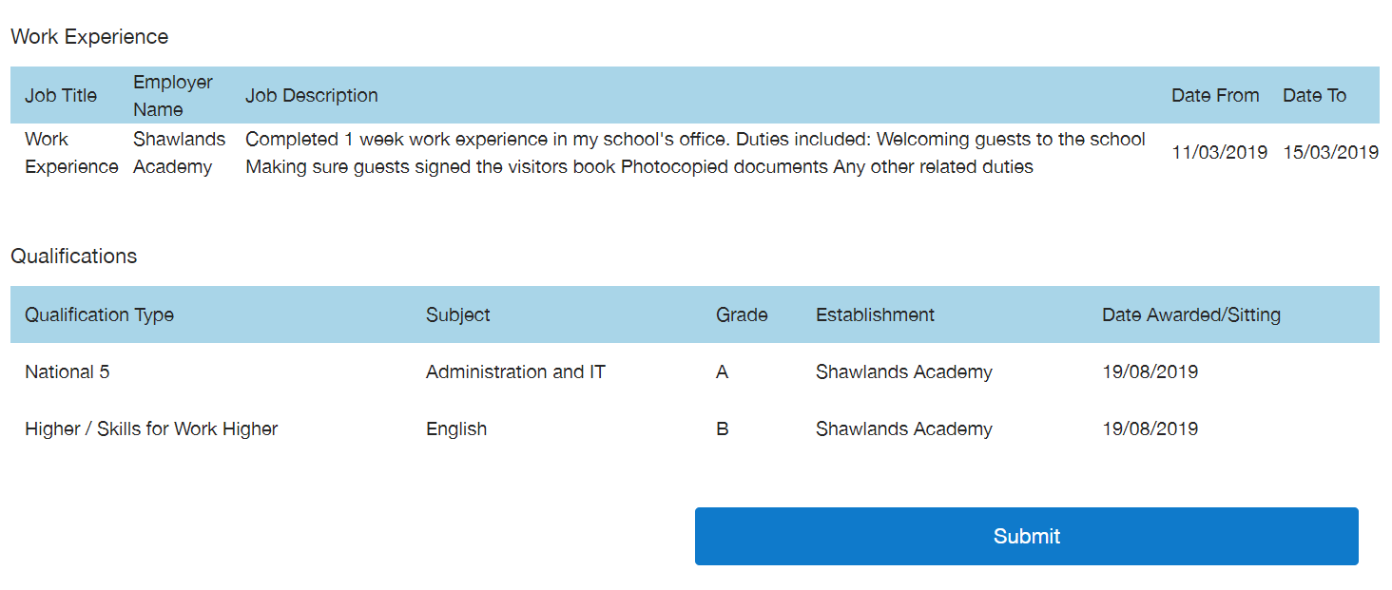

* If you have completed the qualifications, work experience and key skills sections in your account, the information will already be copied over into the application form
  + You can edit any of these sections in your application form
* The red question mark provides hints and tips on how to answer
* Word count is available to check how many words have been written
* There is a **1 HOUR time limit on completing the application**
  + An alert will pop up when the hour is near
  + You can submit your application and edit/amend it later from the **‘Application History’**, but **only** if the vacancy is still live.

**APPLICATION QUESTIONS**

**Why Have You Applied for This Position?**

Key things to consider in your answer:

1. Why are you interested in this apprenticeship/job?
2. Why do you think you would be good at the apprenticeship/job?
3. What do you know about the apprenticeship/job and what is involved?
4. 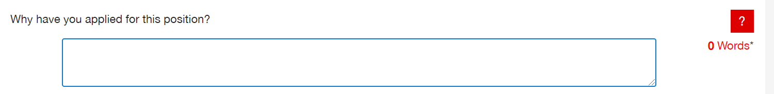What do you know about the company you are applying too? If nothing, do some research!

**Key Skills:**

Key things to consider in your answer:

1. What key skills do you have, which are relevant to the role you are applying for?
2. Look at the job description and think about what you need to be good at, to do the job/apprenticeship.
3. 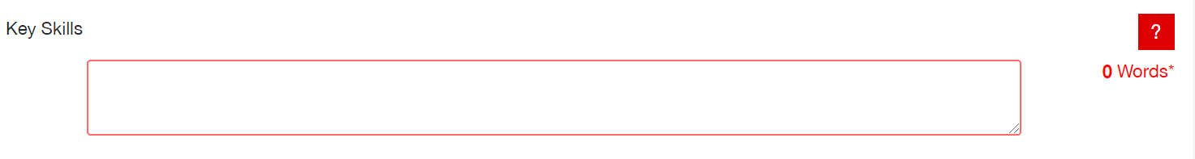Give examples of things you have done or studied that show your skills, which match the job/apprenticeship you are applying for.
4. Some examples of skills are teamwork, organisation, customer service, communication, IT literate, time management and problem solving.

**Qualities:**

Key things to consider in your answer:

1. What qualities do you have, which are relevant to the role you are applying for?
2. Look at the job description and think about what qualities you need, to do the job/apprenticeship.
3. 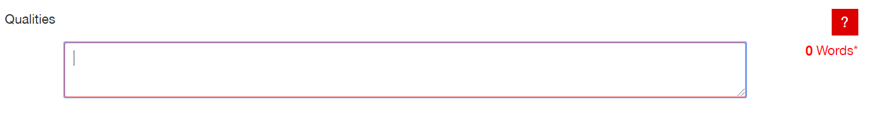Some examples of qualities are honesty, kindness, good work ethic, loyalty, trustworthiness, responsibility, and reliability

**Supporting Statement:**

Key things to consider in your answer:

1. Any other information you may wish to be considered in your application that is relevant to the apprenticeship/job.
2. What are your hobbies and interests: are you a member of any clubs/groups/teams?
3. Mention any work experience including work placements and voluntary work.
4. 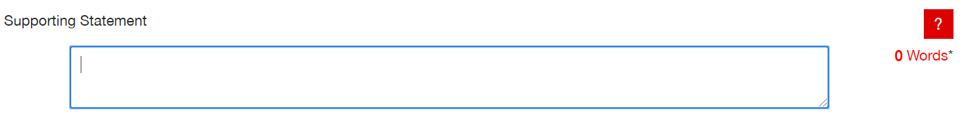Some roles require a driving licence, so you could mention if you have one or are currently taking lessons.

**HOW TO UPLOAD YOUR CV AND COVERING LETTER**

When you have found an apprenticeship or job opportunity that you want to apply for, please click the **‘Apply’** button at either the top or bottom of the job description.

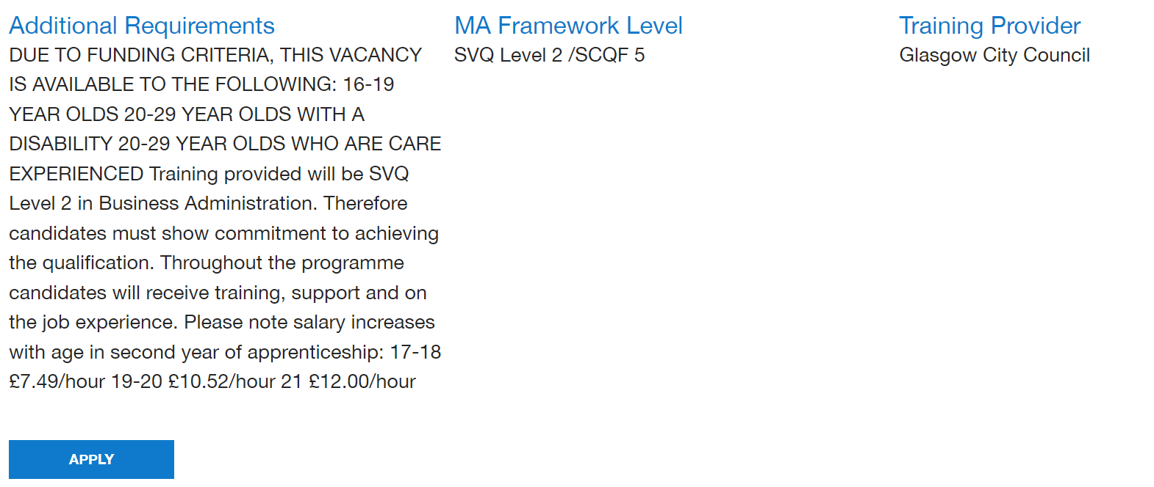

To upload your CV and Covering Letter, click on Choose file and upload, then click submit

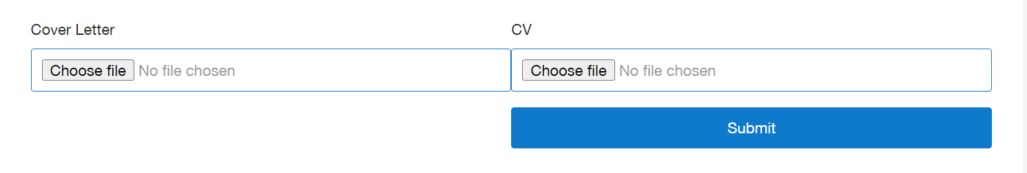

Please make sure your CV and Covering Letter is up to date and has the correct contact details for you

**HOW TO EDIT YOUR APPLICATIONS**

When you have submitted your application, you can still edit the application form or upload a new CV and Covering Letter, but **only** if the job or modern apprenticeship you are applying for, is still being advertised and not reached the closing date.

To view your applications, go to your account and click on **Application History**

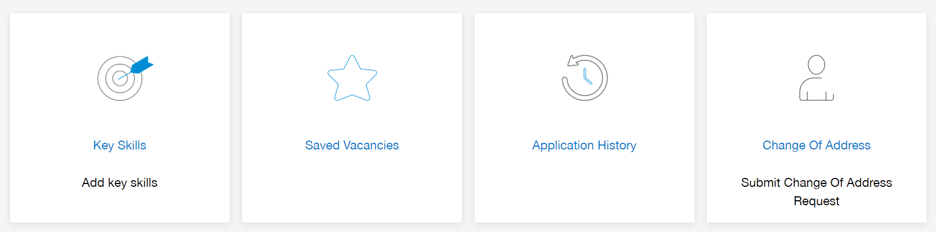

A list of all your submitted applications will be displayed. Click on **View** to open your application/CV:

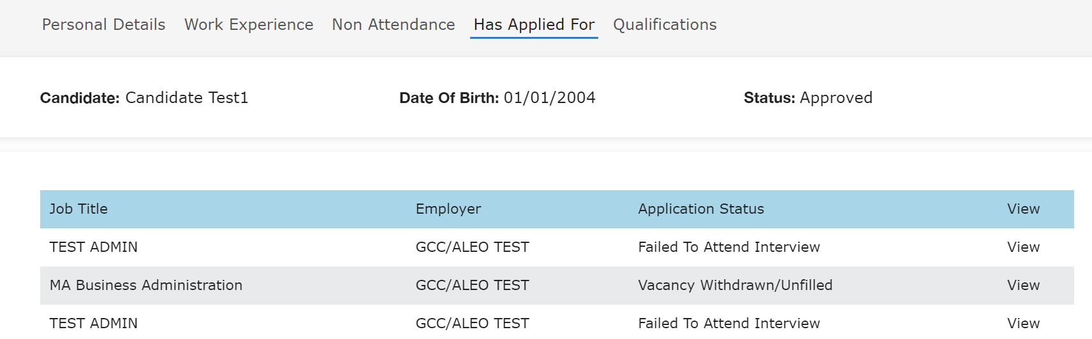

To edit your application or CV/Covering Letter, click on the pencil/paper icon under ‘Update’

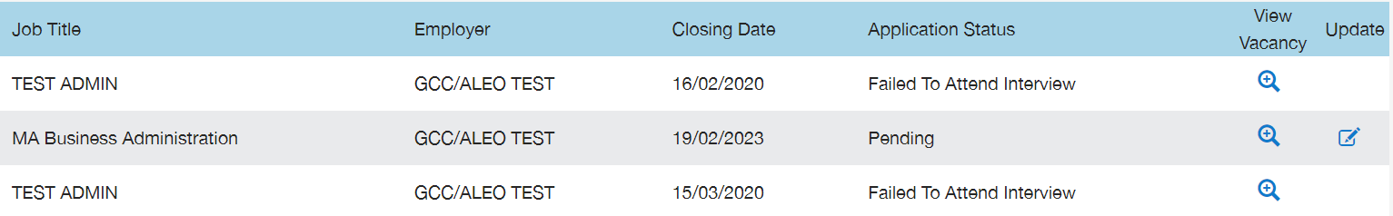

To view the vacancy details/job description, click on the pencil/paper magnifying glass icon under ‘View Vacancy’

**HOW TO CHECK THE PROGRESS OF YOUR APPLICATIONS**

You can check the progress of your applications in your ‘Application History’. There will be an update to your application status that you should check regularly.

The different application status and what they mean are:

**Pending**

Vacancy is being advertised and has not reached the closing date

**Application In Process**

Applications are being considered by the employer

**Application Not Shortlisted**

Application is not being considered further

**At Interview Stage**

Employer is arranging interviews

**Offered**

You have been offered the job/modern apprenticeship

**Successful**

You have started the job/modern apprenticeship

**Interview Unsuccessful**

You were unsuccessful at interview/application

**Vacancy on Hold**

Employer requested vacancy to be placed on hold

**Vacancy Withdrawn/Unfilled**

Employer requested the vacancy be withdrawn or has no suitable applicants

Remember to check your emails for any invitations to attend an interview and respond to any missed calls/messages from an employer