GLASGOW GUARANTEE
Registration Process for Job Ready Candidates
ELIGIBILITY
All candidates MUST:
- Live within Glasgow City Council postcode boundary
- Be unemployed or underemployed (working part time or a 0 hours contract job) and are eligible to work in the UK
- Have recourse to receive public funds
- Assessed as being ‘job ready’

There are 2 entry routes to register:
- Unemployed or underemployed and working with a Glasgow Guarantee Employability Provider

- Being made redundant within the next 3 months, working with, and can be verified by Partnership Action for Continuing Employment (PACE) - Skills Development Scotland

REGISTRATION PROCESS

The registration process includes the following steps:
- Online registration form
- Uploading eligibility documents

Candidates will have access to their account and be able to view vacancies after they submit the online registration form, however they WILL NOT be able to apply for any vacancies, until all the above areas are complete, and the candidate has been approved by Glasgow Guarantee.
Registrations can only be approved once all steps have been completed and all documents are accepted.

GETTING STARTED
To Register with Glasgow Guarantee, go to www.glasgowguarantee.org and click on #READY TO WORK and then Register Now to start registering.
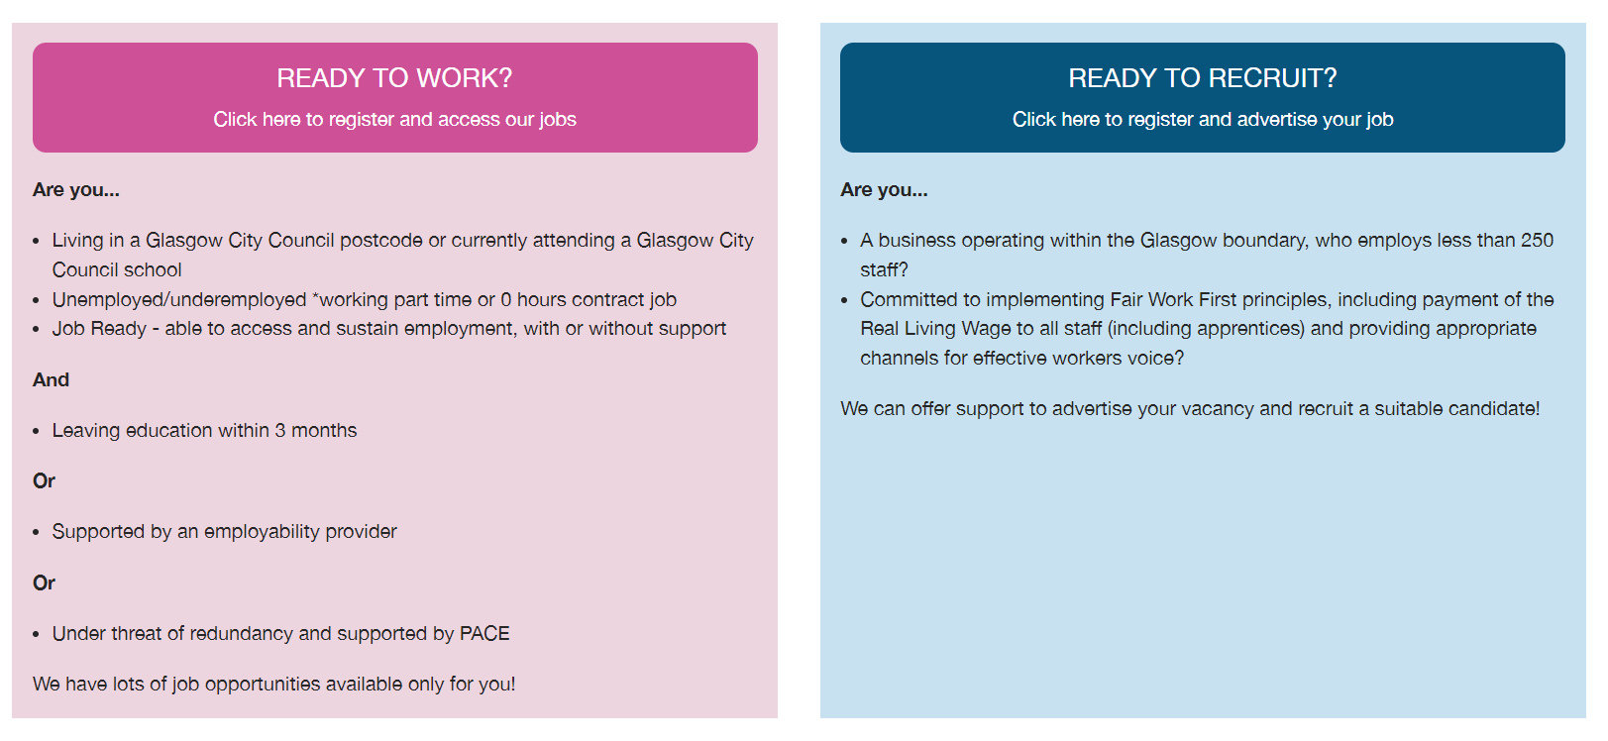
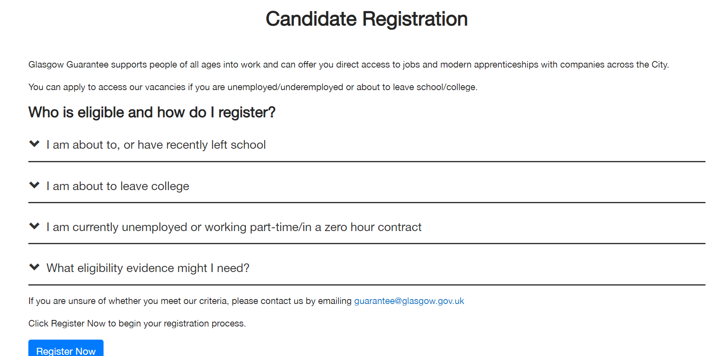

PRIVACY POLICY

As we are asking for personal information about you, we have a Privacy Policy which explains how we keep your information. To find out how we will process and use your personal information, go to https://www.glasgowguarantee.org/Home/PrivacyPolicy

STEP 1: ONLINE REGISTRATION FORM

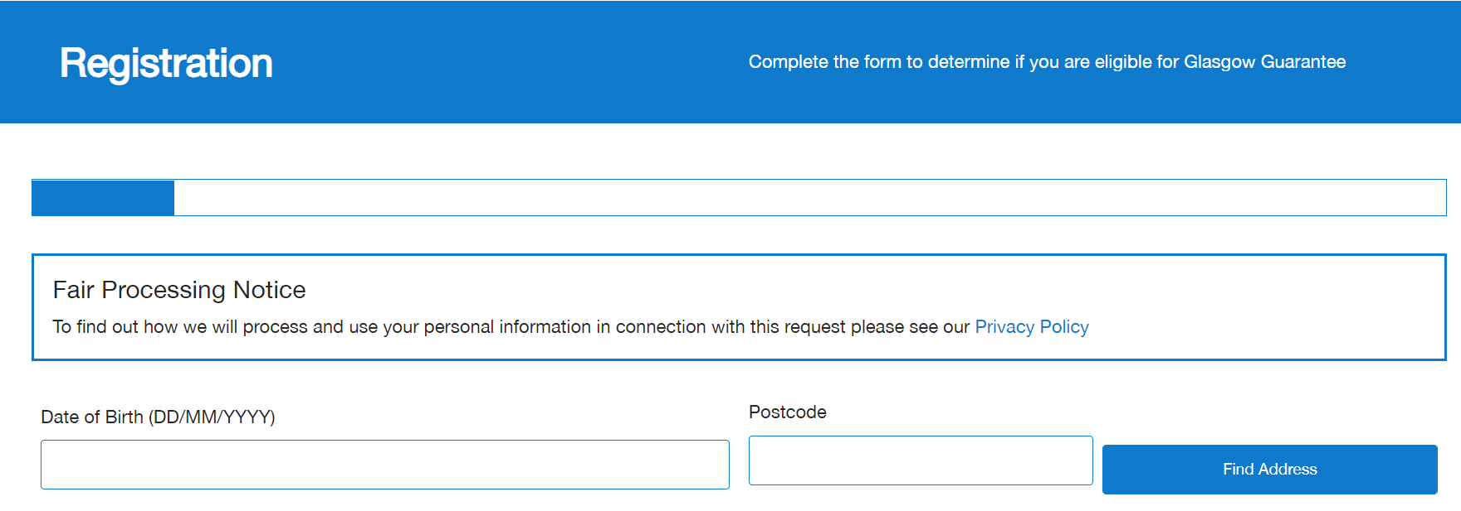

- Enter date of birth

- Enter a valid Glasgow City Council postcode. To check that the postcode is within Glasgow City, please access www.gov.uk/find-local-council

Click ‘FIND ADDRESS’

STEP 1: ONLINE REGISTRATION FORM

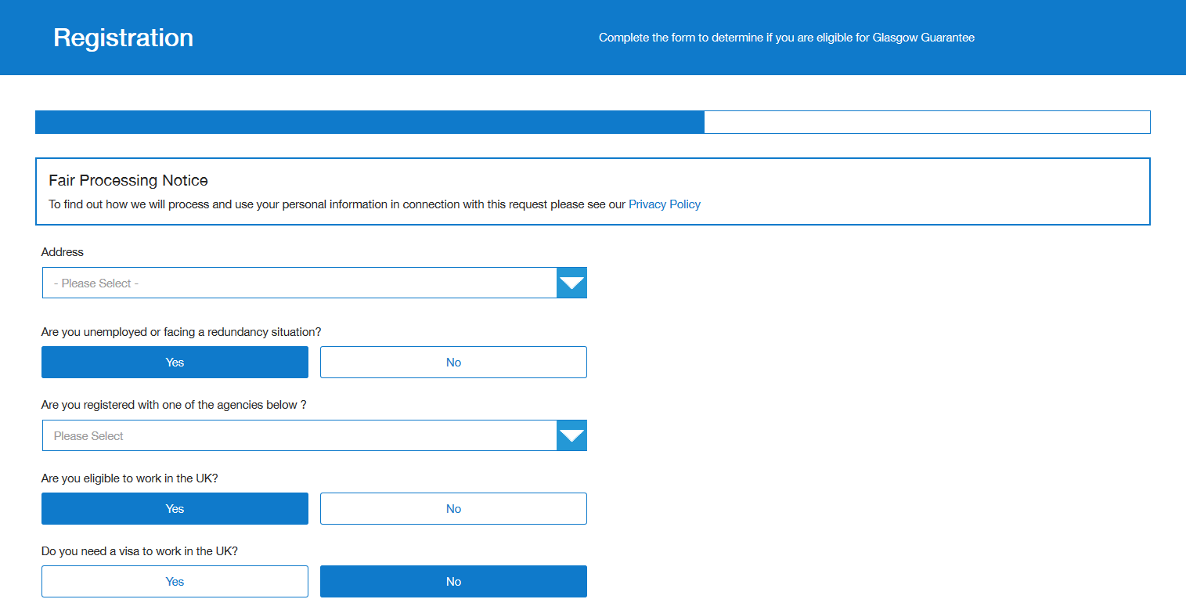

- Select address from the drop-down list.

- Are you unemployed or facing a redundancy situation?
  - Select YES or NO
  - If NO, a message will be displayed advising that you are ineligible for Glasgow Guarantee

- Are you registered with one of the agencies below?
  - Select from the drop-down list of Glasgow Guarantee Employability Providers
  - If you are not currently registered with any providers shown on the drop-down list, select ‘NOT CURRENTLY REGISTERED’. A pop up will appear to give you next steps.

- Are you eligible to work in the UK?
  - Select YES or NO

- Do you need a VISA to work in the UK?
  - Select YES or NO
  - Accepted VISA for registration include:
    - Indefinite leave to remain/settlement
    - Biometric Residence Permit
    - Ukraine Extension Scheme
    - Letter from the Home Office
    - Share Code
    - Universal Credit Screenshot
    - A certificate of registration or naturalisation as a British Citizen
    - EU Settlement Scheme

PERSONAL DETAILS:

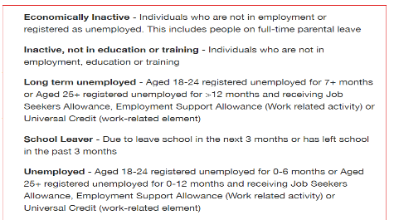
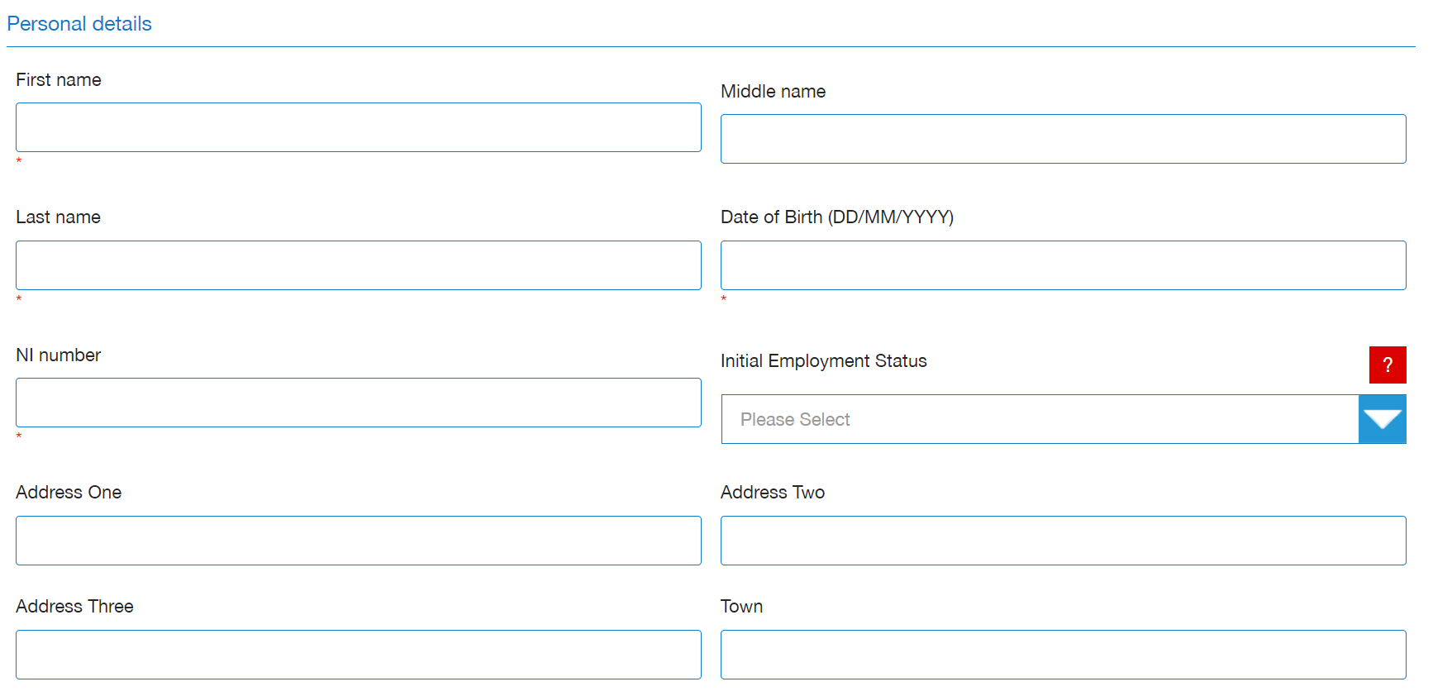

- There are 4 mandatory fields in the personal detail section. Please complete these
  - First name (optional Middle name)
  - Last name
  - Date of Birth
  - National Insurance Number
If you don’t have a National Insurance number, please contact Glasgow Guarantee at Guarantee@glasgow.gov.uk
- Initial Employment Status - you should select the employment status which matches your circumstances in this dropdown
- Complete Address One, Two, Three and Town as required. Continue to complete the form, your postcode will be automatically included

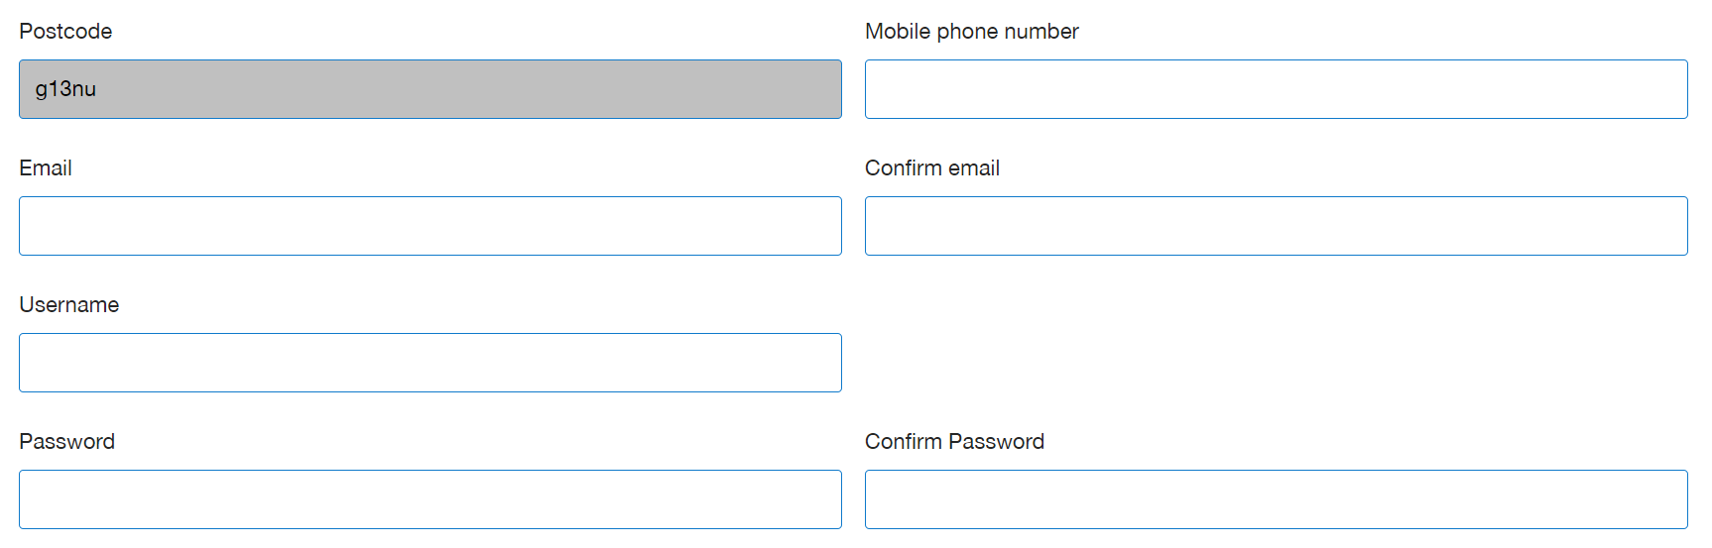

- Add in your mobile number and your valid email address

- Create a Username and Password
  - Think of a username and password that you’ll remember

STEP 1: ONLINE REGISTRATION FORM
EQUALITY AND DIVERSITY:
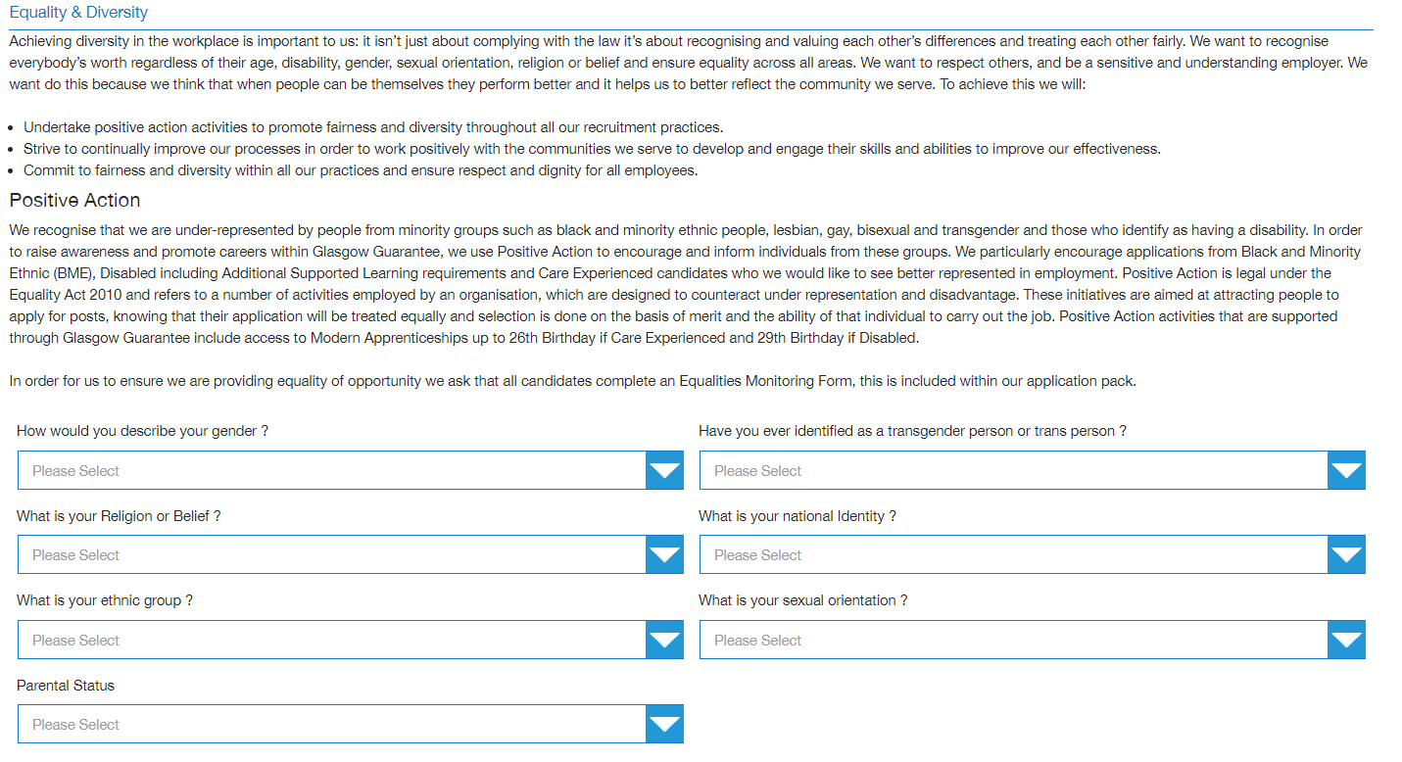
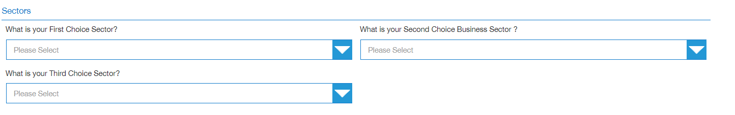
- Complete the equality and diversity form

- Career sectors should be selected in order of preference – first, second and third choice. These can be changed once your registration is approved

STEP 1: ONLINE REGISTRATION FORM
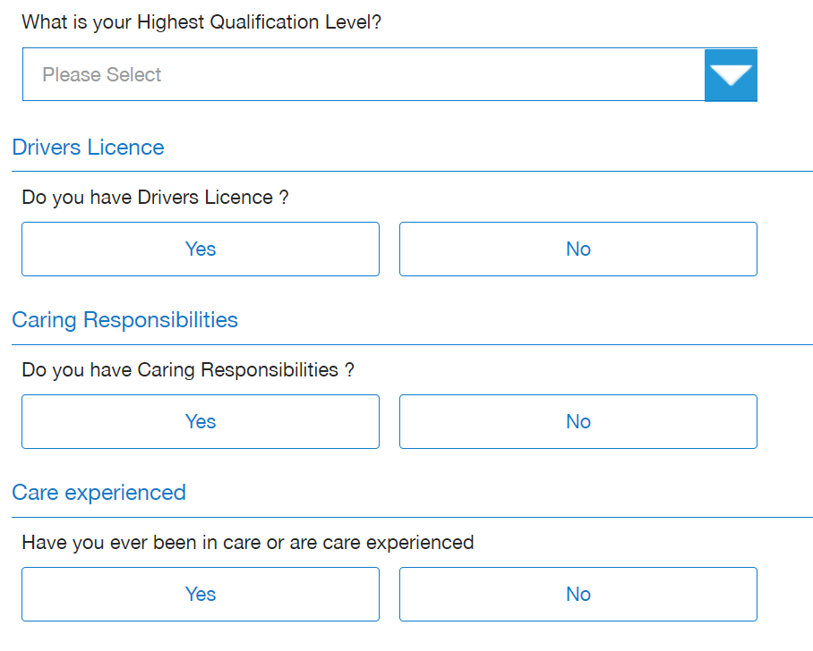

- Qualification Level – select the highest level of qualification achievement you have gained from the dropdown list e.g. National 4, Higher



- Please indicate if you have a disability and require any adjustments in an interview with an employer

STEP 1: ONLINE REGISTRATION FORM

- Barriers should be selected if they are relevant to your current circumstances. Click on the “?” to reveal the definition of each barrier. Multiple barriers can be selected in this section. Definitions are as per ESF Guidance - https://www.gov.scot/publications/european-social-fund-participant-guidance/
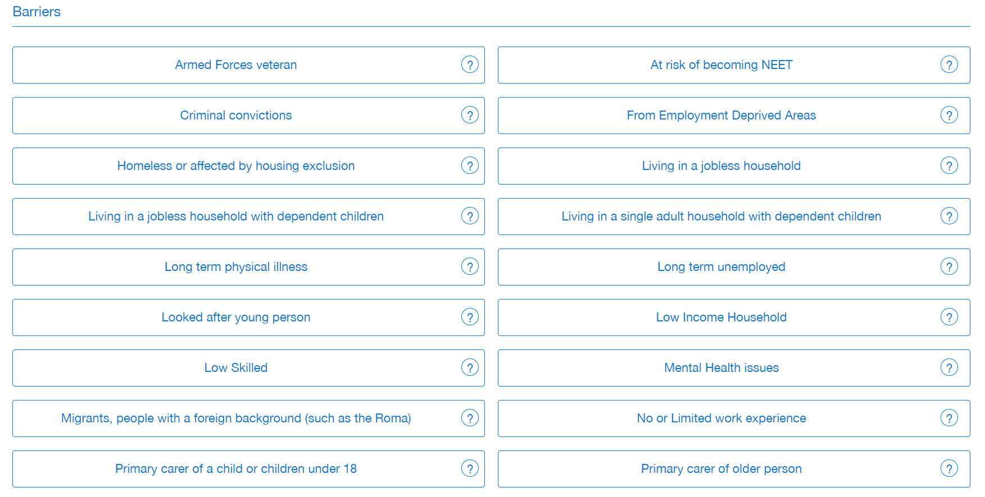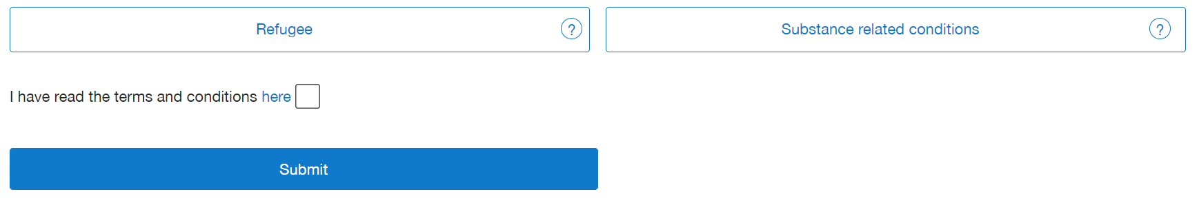
- Read the terms and conditions and data protection information (you can read this via the link below)
  - www.glasgowguarantee.org/CandidateRegistration/Index#
  - Tick the box
- Submit your online registration form
Once you submit your registration form, you will be automatically logged in to your account, but you will not be approved at this stage. You will be able to view vacancies but WILL NOT be able to apply until you complete the full registration process and have been approved by Glasgow Guarantee.
IF USING A PUBLIC PC, PLEASE DO NOT AUTOSAVE YOUR USERNAME AND PASSWORD – other people using the PC after you will be able to log in to your account
EMAIL ADDRESS VERIFICATION

Once you submit your online registration form, you are automatically signed into your account.
You will also receive an email containing a link to validate your email address. We will send you an email (see below) to the email address you provided on your online registration form.
Please note, your registration WILL be progressed if you decide not to validate your email.

Example email:
Thank you for registering with the Glasgow Guarantee. You are now able to validate your email address and can do this by clicking on this link
Please note, your registration WILL be progressed if you decide not to validate your email
Kind Regards
Glasgow Guarantee Team

When you are logged in to your account, your dashboard will look like below:
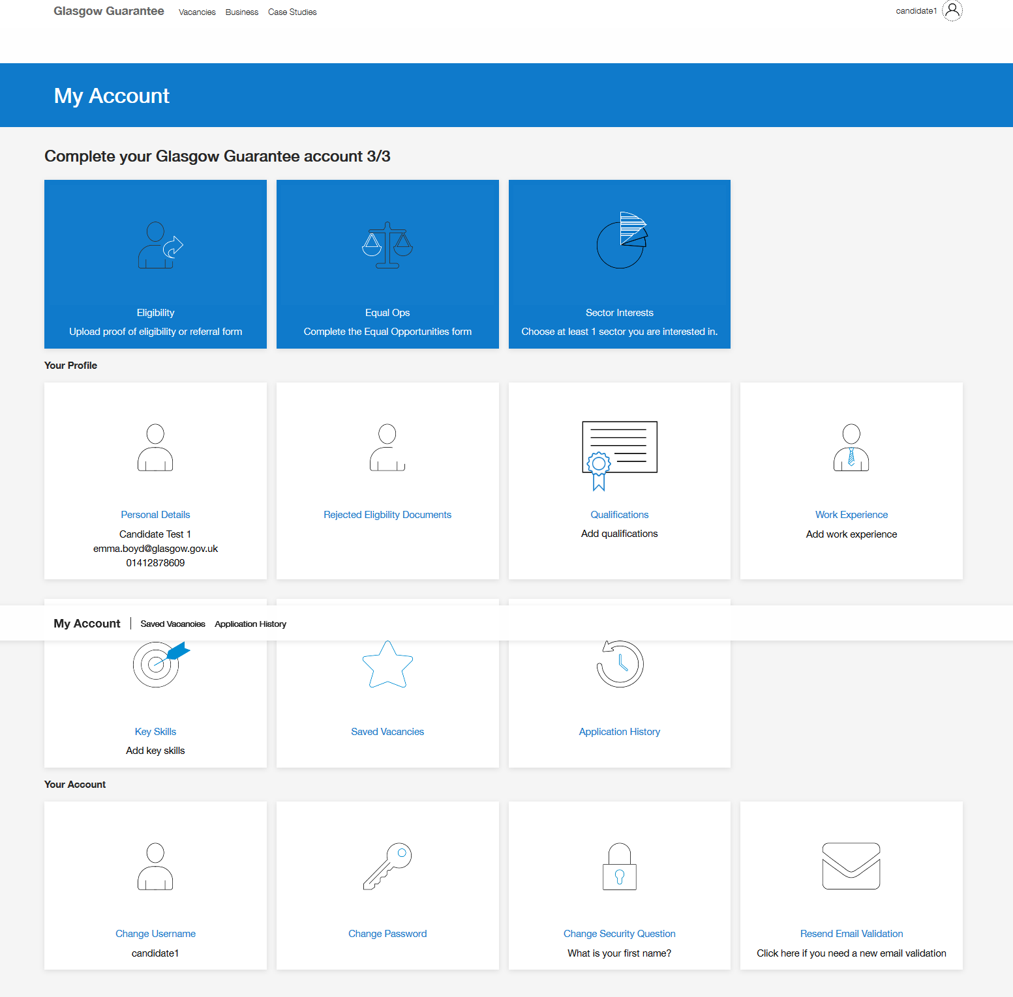

STEP 2: UPLOADING ELIGIBILITY DOCUMENTS:
To complete the registration process, you MUST upload documents to the Eligibility Check section:
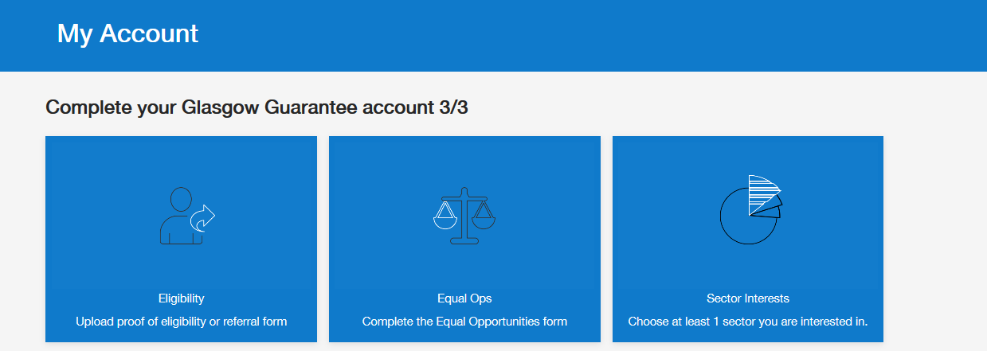
There are 3 mandatory document categories:
- Proof of Address (letters must be dated within the last 12 months)
  - Bank Statement
  - Council Tax Letter
  - Driving Licence (full or provisional)
  - NHS Medical Card
  - Official Correspondence (DWP, HMRC, NHS)
  - Utility Bill
  - DWP Verification Form
  - SDS Letter

- Proof of Right to Work
  - Birth/Adoption Certificate (EU Member State)
  - DWP Benefit Award Letter
  - DWP Verification Form
  - Home Office Online Right to Work Checking Service
  - Marriage/Civil Partnership Certificate
  - National ID Card
  - National Insurance number (Letter/Card)
  - Residency Permit/Evidence from Home Office
  - Valid or expired UK Passport

- Referral/Validation Form
  - Referral Form – to be completed by your employability provider and emailed to Guarantee@glasgow.gov.uk
  - If you do not have support from an employability provider, please contact either Jobs and Business Glasgow or Skills Development Scotland and ask to be referred to Glasgow Guarantee
    - Skills Development Scotland - GlasgowDutyTeamLeaders@sds.co.uk
    - Jobs and Business Glasgow – contact@jbg.org.uk
Once all steps are completed, eligible registration applications will be approved by Glasgow Guarantee

